DirectX 11 Tutorial 19 – Particles

This week's tutorial focuses on a simple parametric particle system.

You are required to:

Construct world matrix so that billboard always faces the camera and apply

1. Compute camera ortho normal basis ( fire_VS.HLSL)
2. Transform the particle positions to face the camera( fire_VS.HLSL)

Blend modes - Enable alpha blending

1. modify the fire blend states to enable alpha blending (Scene.cpp)
2. observe the artefacts when rendering particles. What is the cause?

Depth Buffer - Disable depth writing

1. modify the fire depth stencil states to disable depth writing (Scene.cpp)
2. observe the artefacts when rendering particles. What is the cause?
3. Add smoke to the fire.

If you complete this task continue with your coursework.

Download the source code for week 19

Review the week 19 lecture notes "Lecture 19 - Particles " and complete the following tasks:

Task 1

Search the source code for the comments ( fire_VS.HLSL):

// Add Code Here (Compute ortho normal basis)

Construct world matrix

Task 2

Search the source code for the comments( fire_VS.HLSL):

// Add Code Here (Transform particle verticies to face the camera)

Transform the particle positions using the world matrix

Task 3

Search the source code for the comments(Scene::initSceneResources()):

// Add Code Here (Enable Alpha Blending for Fire)

Modify the fire blend states to enable alpha blending

Task 4

Observe the artefacts when rendering particles. What is the cause?

Task 5

Search the source code for the comments(Scene::initSceneResources())

// Add Code Here (Disable Depth Writing for Fire)

Modify the fire depth stencil states to disable depth writing .

Task 6

observe the artefacts when rendering particles. What is the cause?

Task 7

Create a second ParticleSystem that uses the smoke texture to add smoke to the fire.

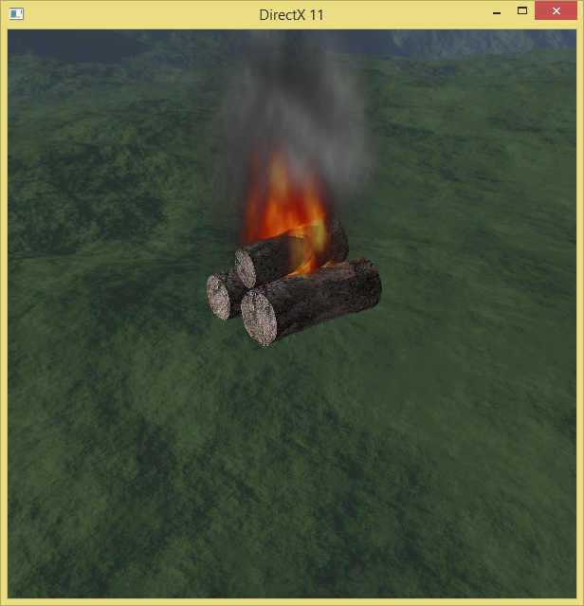 Finished !